**HEXADECIMAL TO DECIMAL CONVERSION**

**EXP NO: 27**

**AIM:** To write a C program to implement hexadecimal to decimal conversion.

**ALGORITHM:**

1)   Start from the right-most digit. Its weight (or coefficient) is 1.

2 . Multiply the weight of the position by its digit. Add the product to the result.  
(0=0, 1=1, 2=2, … 9=9, A=10, B=11, C=12, D=13, E=14,F=15).

3)   Move one digit to the left. Its weight is 16 times the previous weight.

4 ) Repeat 2 and 3 until you go through all hexadecimal digits.

**PROGRAM:**

#include<stdio.h>  
int  
main ()  
{  
   int n;  
 print f ("enter the hex decimal number");  
 scan f ("%x", &n);  
 print f("the decimal value is:%d" ,n);  
   return 0;  
}

**INPUT:**

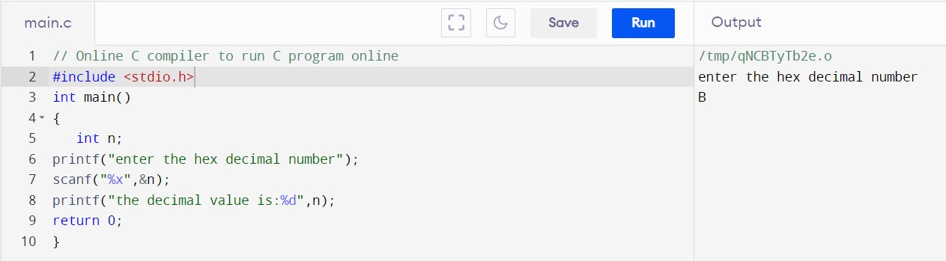  
  
  
  
  
**OUTPUT:**

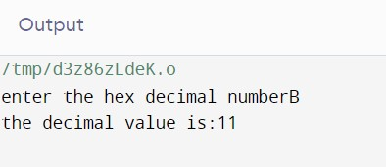  
  
  
 **RESULT:**Thus the program was executed successfully using Dev C++.